*To err is human, to forgive divine.*

Much too often we’ve made mistakes which knowingly or unknowingly we are going to repeat, and yet promise not to make the same mistakes again. One of the mistakes that I often make and which I’ll correct here is to generalize what applies to me alone. Henceforth, I speak for myself, there is only ‘I’ and ‘me’ and no ‘we’ when making claims. Hence.

Much too often I’ve made mistakes which knowingly or unknowingly I am going to repeat, and yet promise not to make the same mistakes again and loop.

Some mistakes are imbibed with birth, and are made when all other mistakes are being committed in succession and things are falling apart like the domino effect accompanied by a train of ‘Oh Shit!’s and curses.

*To err is in humans bred,*

*Doubt and fret, than to seek instead.*

The wisdom of our ancestors was passed down in undiminished quantities through our genetic code. We have the combined wisdom of what our mothers and fathers had while our seeds were sown, and the wisdom that we gained thereafter on our own. It’s not forbidden to have it, but it’s never too apparent either, it takes a *little something* to decode a code, the piece of Eden some desperately seek.

*I plucked the finest roses from the gardens,*

*Stuck them in pages and laid them on dry tombs,*

*While poets struck in them the finest tunes,*

*I in my naiveté merely hummed along.*

[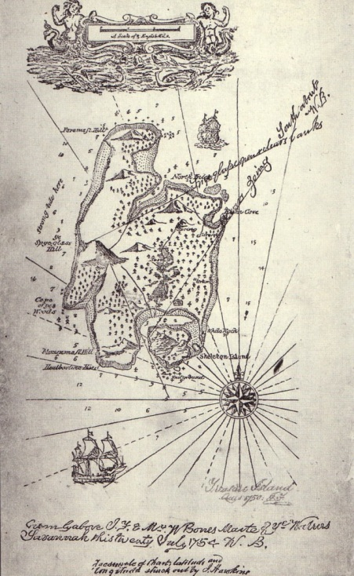](http://weaponsgradeennui.files.wordpress.com/2010/09/treasure-island-map.jpg)

I gaze at the prose and pieces written by poets and sit helplessly in amazement and wonder, with little success what might have prompted them to write something that continues to live long after their creators are sleeping cold, and what influence? They are subtle, powerful and the influence is still unabated.

*The ciphers from distant lands,*

*Travelled far and wide,*

*To land up in unworthy hands,*

*For all their efforts despite?*

 In the simple nuances of the forgotten poets do I find the clues holding promise to be the key of what I seek. What I seek, is something I am not too sure of, it is like looking across a waterfall and that is why I want to know it all.

*Masters scrambled the words to conceal,*

*Roads leading to the treasure’s post,*

*Plain as the nature is, needs but plain sight to see,*

*The wisdom long gone, was never lost.*

I’ve met people, I’ve liked people, and I’ve disliked people, formed opinions with what they looked like or behaved like. I like to believe that most of us live many lives, and seldom the real life. Even when alone, we are trying to mould ourselves, in a bid to outdo ourselves and become something that we think would make us better, but would regret sooner or later do to loss of intrinsic nature. But then again, I’d only want to talk for myself. I live like that. Part apologetic, part hypocritical, part proud and part self mocking. People mock me, I mock people, and sometimes wonder what made me like that? A little thing of beauty that semiconductors have taught me is that once they are doped, they become more conducive to be operated upon. They conduct more, and hence, react to little stimulus in a way they would have when subjected to their extremes when in their intrinsic states.

*The cause of fall of Eden,*

*Just because of a tree?*

*That feels just so wrong.*

They tell me to depart from mediocrity if I am to shine, and allow my heart and mind to judge, the feel and the sense. Don’t get me wrong if I hush myself after vehement blows. It’s not subjugation or diffidence; it’s not surrender, at all. I repair myself when no one watches.

*To err is human, to forgive divine.*

(Redundant, rhetorical.)